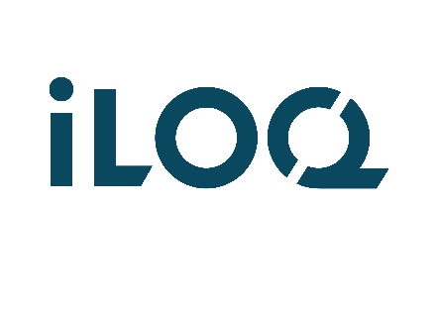

**INFORMATION SECURITY POLICY**

iLOQ Oy

Last Modified: 11 November 2024

## INFORMATION SECURITY POLICY

This Policy provides a framework for the information security objectives which align with iLOQ’s purpose, values and strategic priorities. Information security objectives and their metrics are defined and monitored according to the annual plan. iLOQ complies with the requirements of ISO 27001:2022.

We observe and fulfil information security requirements regarding our products, software solutions and operations that are received from interested parties as well as those laid out by regulations, applicable laws, and other compliance criteria. We commit to satisfy applicable requirements related to information security. We ensure the confidentiality, integrity and availability of information about the organization and stakeholders.

Information security is developed continuously and systematically according to information security management system. We identify the information security risks and plan the needed actions and controls associated with our operation. Deviations detected and opportunities for improvement observed in our operations are handled openly and obtained information is utilized in continuous improvement of processes and methods. Information security is monitored and measured with the aid of operative and information security key figures as well as observed non-conformities. External providers’ information security is also monitored.

The information security policy applies to all levels in the organization. We commit our personnel and stakeholders to conceal in their work assignments confidential information to be processed. Each employee is aware of their effect on information security always, and they are able to initiate and, where necessary, take preventive and corrective actions.

This Policy will be communicated and acknowledged to the whole organization and relevant interested parties through employee inductions, trainings and informal communication methods. The information security policies are reviewed annually and if significant changes occur.

Change history

| **Revision** | **Date**  **(YYYY-MM-DD)** | **Author** | **Change Reason** |
| --- | --- | --- | --- |
| 0.1 | 2022-10-12 | H. Leskinen | First draft (policies for the same documents) |
| 1.0 | 2022-10-12 | H. Leskinen | For approval (by T. Ainali) |
| 1.1 | 2023-03-03 | H. Leskinen | Person in charge changed |
| 2.0 | 2023-03-03 | H. Leskinen | For approval (by T. Ainali) |
| 2.1 | 2023-11-23 | T. Ainali, M-K Kuoppala, H. Ahola, J. Koivula, T. Lappi, T. Karhu, H. Leskinen | Introduction chapter added, policies updated and reviewed |
| 2.2 | 2023-12-01 | T. Ainali, M-K Kuoppala, H. Ahola, J. Koivula, T. Lappi, T. Karhu, H. Leskinen | Policies updated and reviewed |
| 2.3 | 2023-12-12 | Leadership Team E. Sankari, V. Tolvanen, H. Hiltunen, J. Klinga, J. Lampinen, M. Tuomikoski, T. Thörewik, T. Ainali, T. Pirskanen, T. Karjalainen | Reviewed by Leadership Team |
| 3.0 | 2023-12-12 | Leadership Team E. Sankari, V. Tolvanen, H. Hiltunen, J. Klinga, J. Lampinen, M. Tuomikoski, T. Thörewik, T. Ainali, T. Pirskanen, T. Karjalainen | Approved by Leadership Team |
| 3.1 | 2024-03-28 | H. Ahola, MK Kuoppala, J. Koivula, H. Leskinen | Policy reviewed from cyber security point of view. Cyber security added to headline. |
| 3.2 | 2024-09-26 | H. Leskinen | Std and objective references added to information security policy |
| 4.0 | 2024-11-11 | Leadership Team | Reviewed and approved to the presented to the Finance and Audit Committee and thereafter to the Board for approval. |
| 5.0 | 4th December 2024 | Leadership Team | Reviewed and Approved |